East Texas Maneuvers

**Newsletter: The East Texas Piney Woods Motor Pool, Inc.**

**January 2019**



**Mission Statement: To provide an organization for military vehicle enthusiasts, historians, preservationists, and collectors interested in the acquisition, restoration, preservation, safe operation, public education and display of historic military transport.**

**From Our President:**

I hope each and every one had a wonderful Christmas and a happy New Year.

Your Piney Woods officers for 2019 are;

President, Rick Ellison

Vice President, Mike Eckert

Secretary, Mike Gamble

Treasurer, jack Gowen

Newsletter editor, Linda Gamble

This should be a great year for our Chapter. Check out the events calendar as there are already events listed. So, get your OD Green ride serviced and ready to participate. Remember to get your local event scheduled by informing our Secretary so it can be added to our events calendar.

**Please pay your 2019-chapter dues. Please send to Jack Gowen**

I hope to see you soon

Rick

Chapter President

**Members New Projects**

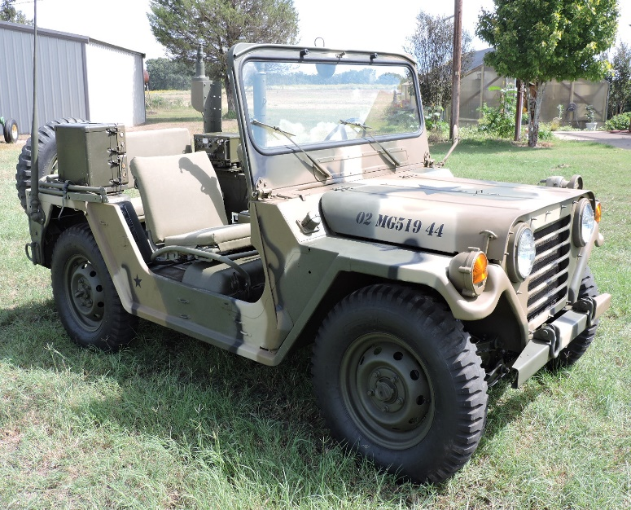 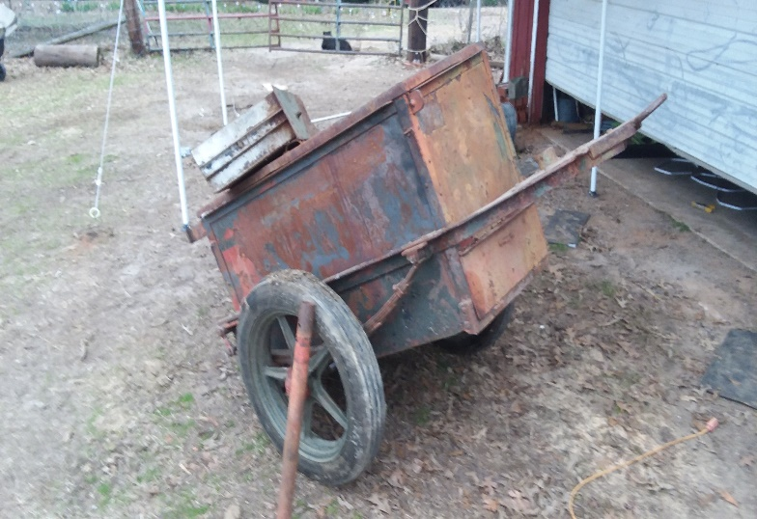

Mike G’s M151A2 finished in late 2018. Here is Tom Townsend’s Linesman Trailer, Starting 2019

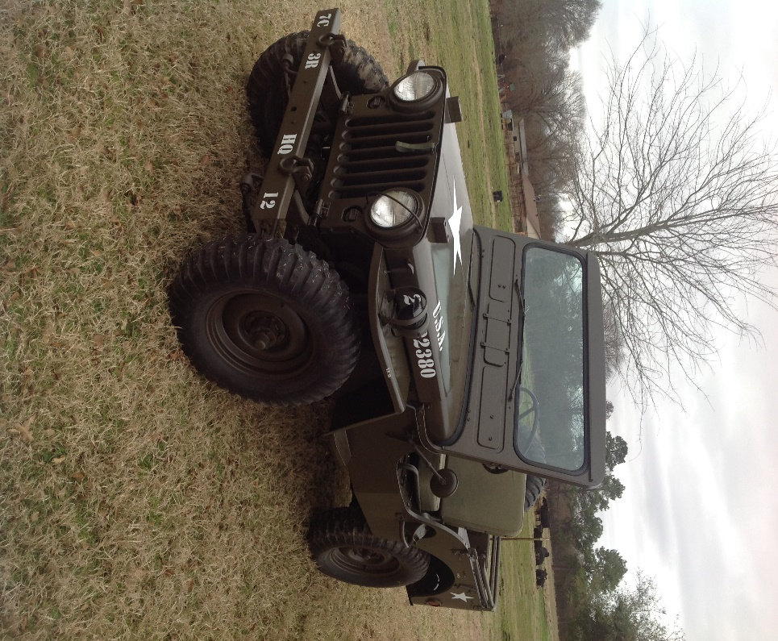This is Rick Ellison’s almost complete M38. Started last year and only needs a few minor items to complete. Looks good Rick!

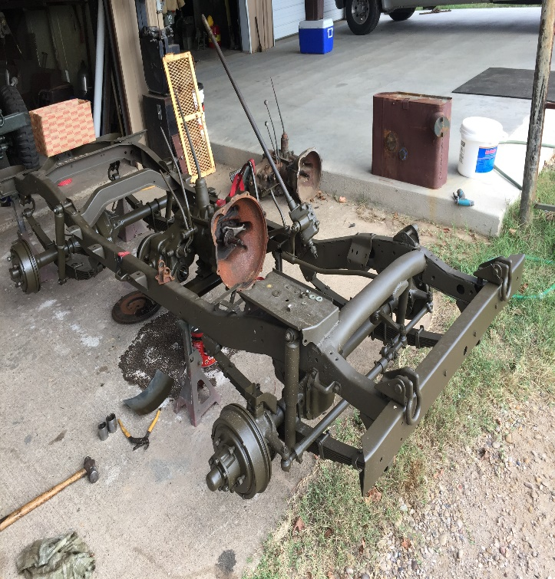

**Past Events**

**ARMVPA RedBall Convoy**

May 5 2018

The Red Ball Convoy this year started in Fayetteville Arkansas and traveled over 100 miles on Saturday. Accomodatons were in Fayetteville and the three members attending, Rick, Mike and Les traveled up on Friday and returned on Sunday. This is one of the premier convoys for Military Vehicles and is attended by the East Texas group every year. The route and organization are excellent and the members of the Arkansas MVPA are the most accomodating and helpful of all convoys we attend. Try to make their 2019 convoy; we will, see you there.

Since I was the one with the camera, I am not in the pictures but this picture is from the first rest stop outside Fayetteville.

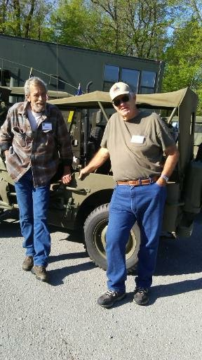 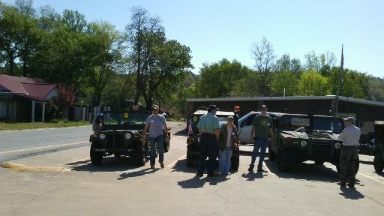

Les and rick leaning on Linda’s Jeep, she let me use it for the convoy. Other participients!

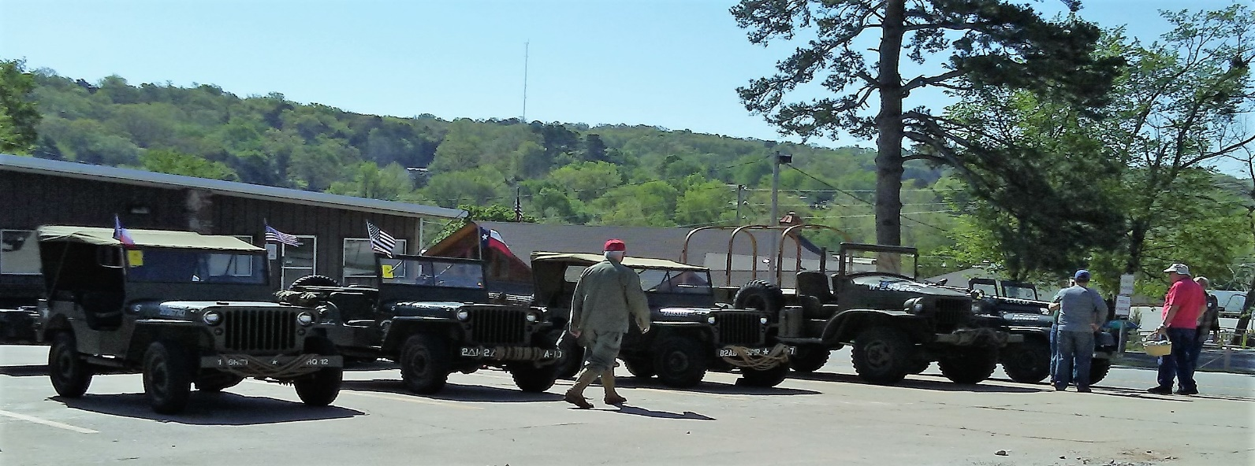

**Mineola Veterans Day Parade**

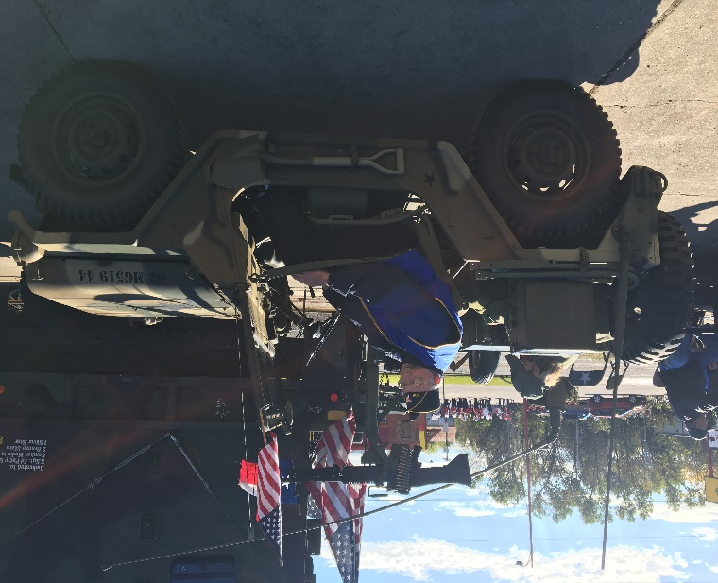 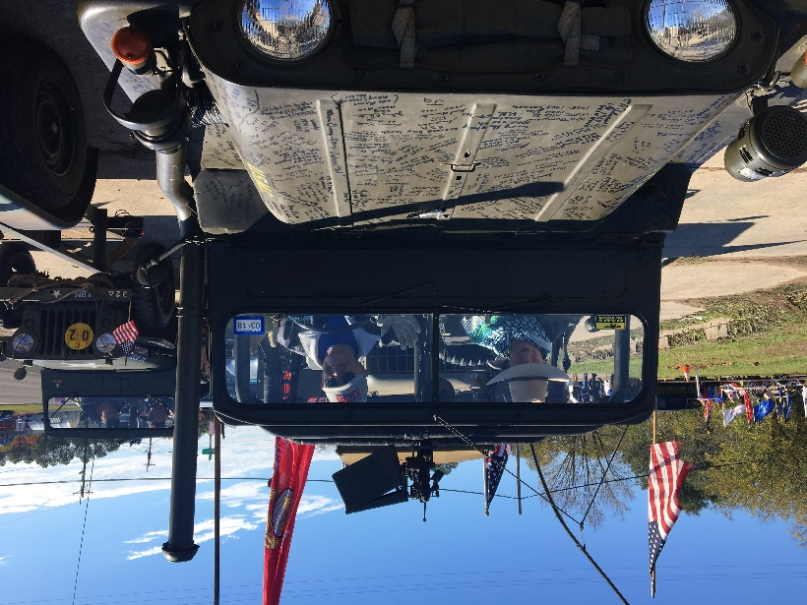

Several members participated in the Meneola Veterans Parade. Here are Ken and Fran, Linda in my

Mutt and Bob in his M151A2 Mutt.

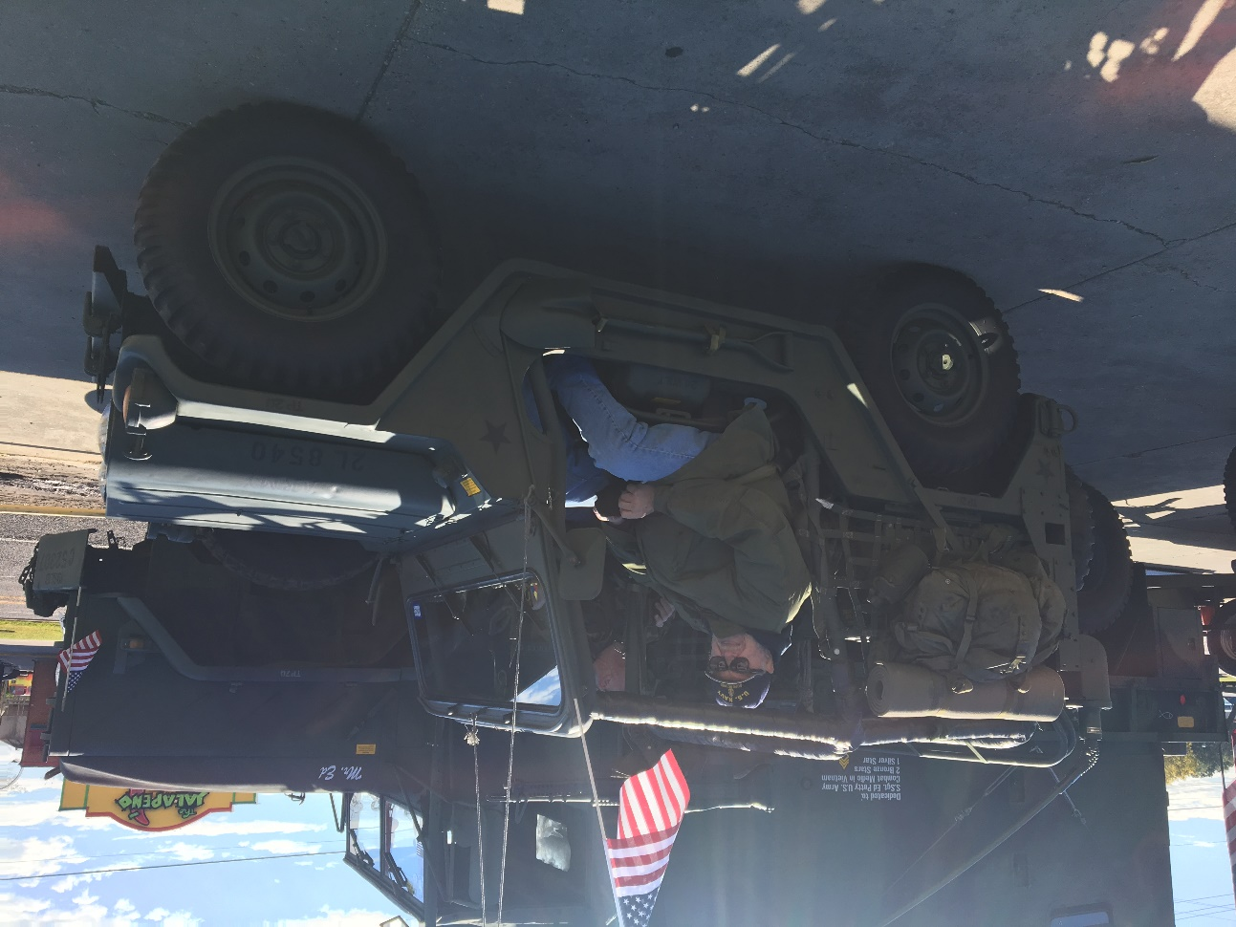

All of the members had Veterans Riding with them. The weather warmed and it was a very good parade and enjoyed by the Veterans. After Action Report @ Mexican Food Restaurant!

**Emory Veterans Day Program**

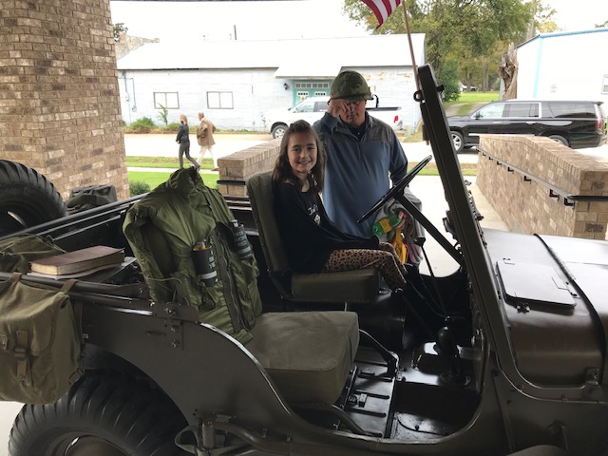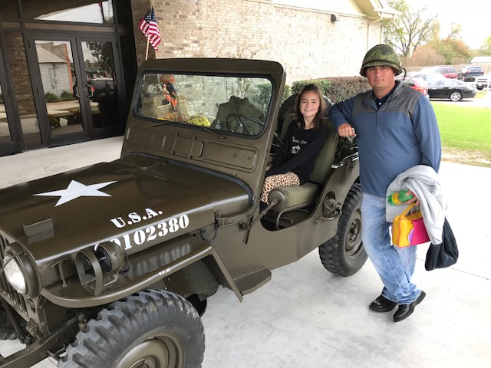

Rick and Hilda’s grandaughter Allison Grace Wallace and father Kody Wallace at the Emory Baptist Church Veterans Day Program

**Ft. Hood HMVR**

**October 19-21**

Several members attended the 3 day Ft. Hood Historic Military Vehicle Ralley. Club members attending were Mike Eckert, Craig Eckert, Mathew Eckert, Steve Eckert and Caleb Eckert, (otherwise knows as the Eckert Clan) Les Branson, Mike Gamble, Michael Loun,

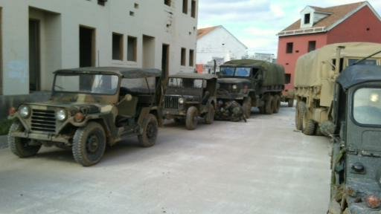 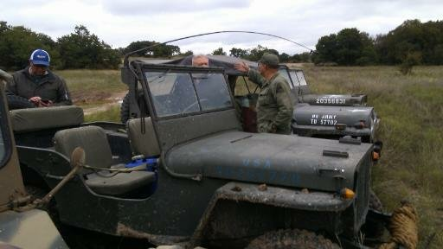

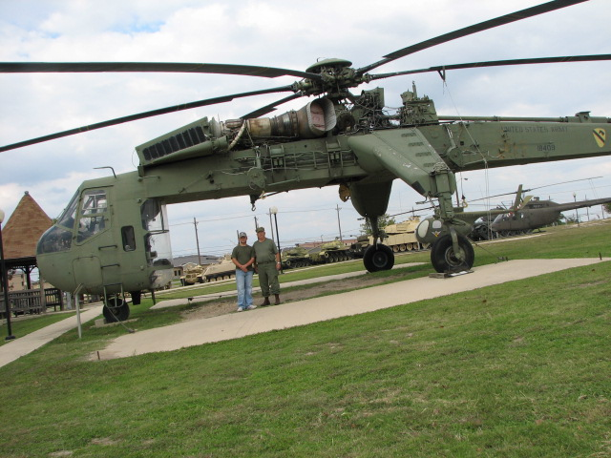

The weather started off rainy with the cancellation of the static display at the Shopette: but a convoy out into the range took its place with lots of mud, water and laughter. The second day, the wx cleared and there was no rain but the mud and high water persisted with a lot of pressure washing to be done at the end of the convoy.

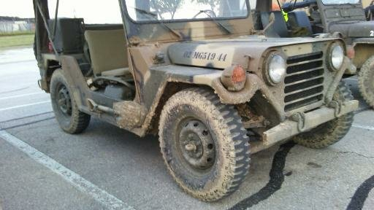

Saturday afternoon we were invited to the 100th Anniversary Celebration. This took place at the stadium with lots of people attending and an opportunity to display our vehicles.

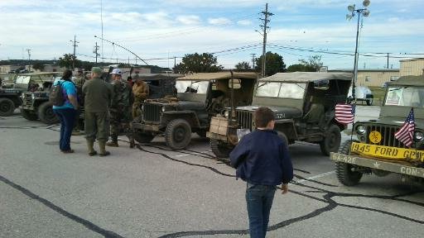 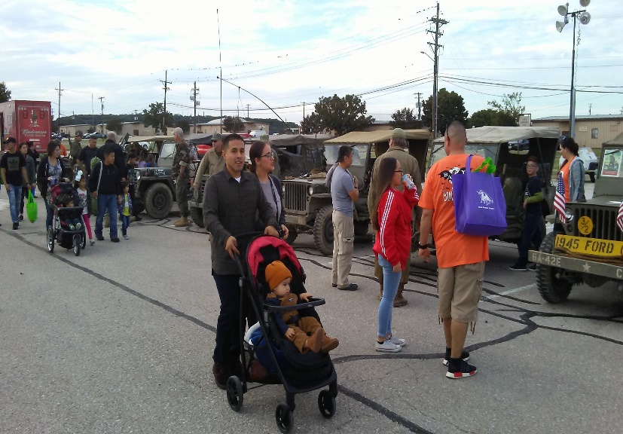

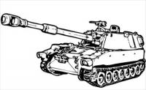

**ETPW Club Convoy**

**November 17th**

We assembled here at the farm on Saturday with warm weather and sunshine. The convoy consisted of Tom and Jan Townsend, Rick and Hilda Ellison, Mike and Linda Gamble, Les Branson, Kent Branson and Bob English. We headed over to Edom thru the back country and stopped for a short break. Then the crew loaded up for a drive down to Brownsboro for another break. We left the Shell station and drove the back country over to Chandler where we ate lunch. After Lunch took a different route back to Edom, Ben Wheeler and back to the farm. The convoy was about 70 miles; no problems.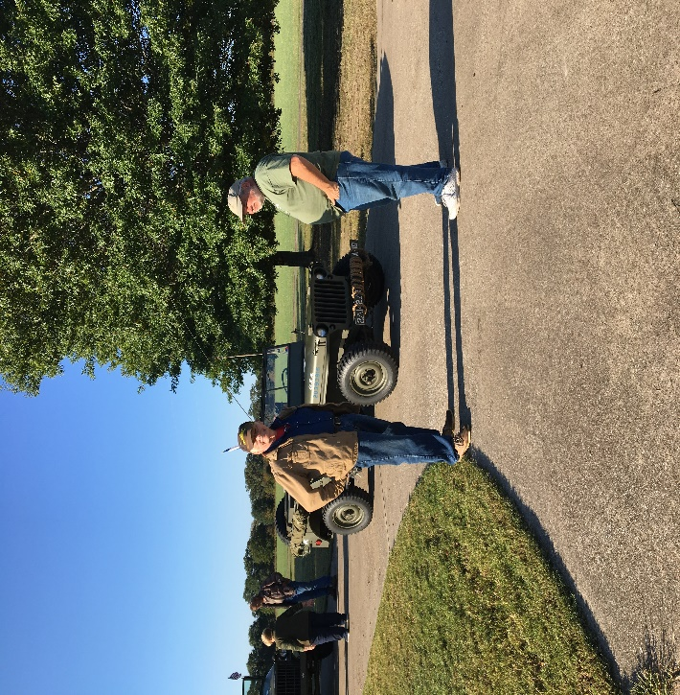 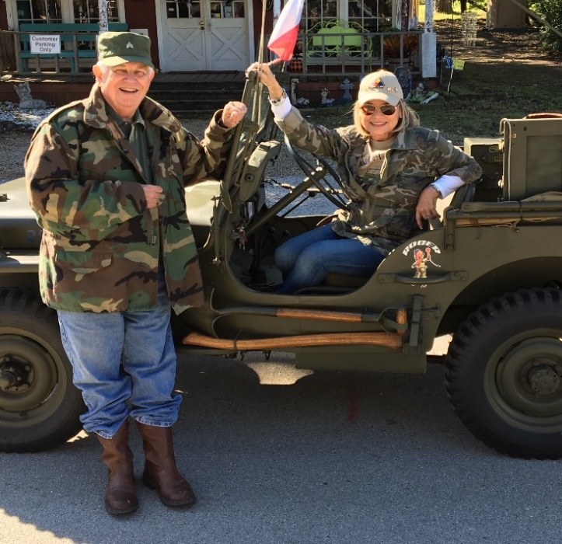

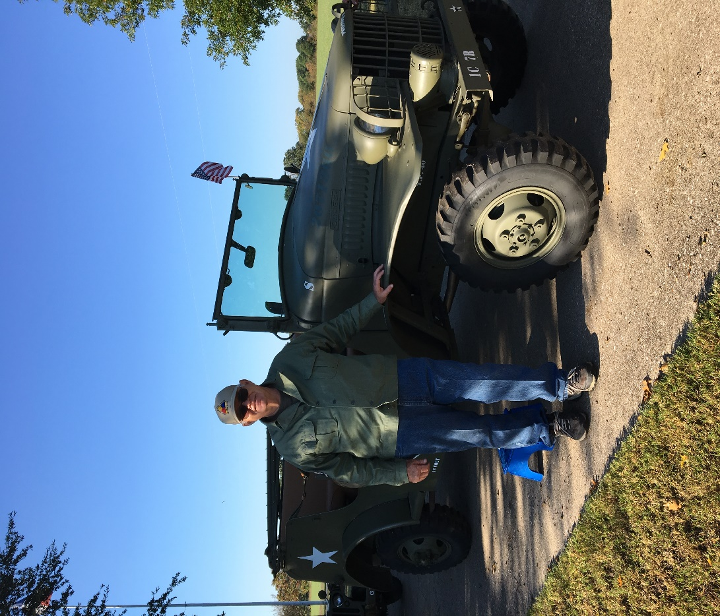

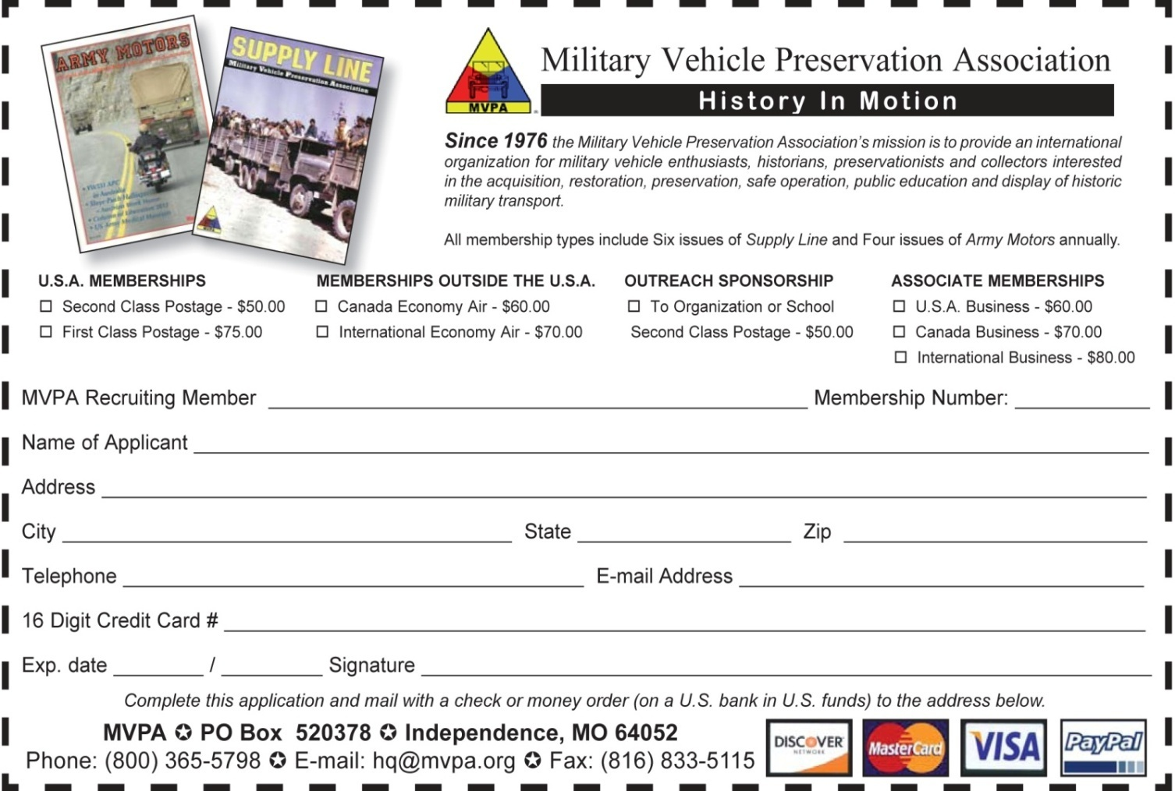

Our Mission

To rescue and preserve the history and memories of discarded military vehicles of America’s past.

The East Texas piney Woods Motor Pool is a chapter of the National Organization, Military Vehicle Preservation Association (MVPA). The goal of our chapter is to restore and preserve these historic military vehicles of our past for the purpose of education and preservation of American history. These vehicles are used in parades, veteran events, car and truck shows and other patriotic events.

Our membership includes current, retired and veteran military personnel as well as non-military members and families. We encourage family participation and involvement in order to help our young to understand that our mission is important. There is no need to have a vehicle to join our organization and we encourage participation of non-owners as we always have equipment that can support additional members and friends.

We meet usually bi-monthly for a short business meeting and to plan coming events. We socialize and discuss the restoration of our vehicles. Sometimes we have local convoys/trips and trail rides. We also participate in events of other MVPA chapters in Texas and surrounding states.

Join us on some of our events or convoys, experience history in motion, Mike Gamble



To Join the East Texas Piney Woods Motor Pool, fill out the following and mail to the address below.

Name_______________________________

Spouse _____________________________

Address_____________________________

City, State, Zip________________________

Phone(H) ____________________________

Phone(C)____________________________Email_______________________________

Military Vehicle_______________________

Cost to Join: **$20**

Mail to The Treasurer: **ETPWMP**

**Jack Gowen**

**18083 N. Lakeview Dr.**

**Troup, Texas 75789**

**Troup, Texas 75789 East Texas Officers:**

Rick Ellison, President[rick73aggie@gmail.com](mailto:rick73aggie@gmail.com)

Mike Eckert, Vice President [eckert334@directv.net](mailto:eckert334@directv.net)

Mike Gamble, Secretary [mikegamble@centurylink.net](mailto:mikegamble@centurylink.net)

Jack Gowen, Treasurer [jigowen@yahoo.com](mailto:jigowen@yahoo.com) Mike Gamble, Events Coordinator [mikegamble@centurylink.net](mailto:mikegamble@centurylink.net)

Linda Gamble, Newsletter Editor [gamblelkg@aol.com](mailto:gamblelkg@aol.com)

Tom Townsend, Activities Director [tom@tomtownsend-toyland.com](mailto:tom@tomtownsend-toyland.com)

**2019 Events**

**March 23-24, 2019 Museum of the American G.I., College Station**

Living history weekend.Military swap meet, reenactments, open museum, armor and other vehicle displays and living history displays. ETPW will get a club spot for the shelter.

<http://americangimuseum.org/website-banner-4/>

**Museum Of The Pacific War, Fredericksburg**

Pacific Combat Zone, Standing on the Beach, This a reenactment show put on by the museum which depicts a beach landing on a Pa

Ecific Island during WW2 Show times are 10:30 and 2:00

March 10&11 April 14 & 15

May 26 & 27 June 16 & 17

July 14 & 15 Sept 1 & 2

October 13 & 14 November 17 & 18

[www.pacificwarmuseum.org](http://www.pacificwarmuseum.org)

**May? ARMVPA Red Ball Convoy, Fayetteville, Arkansas**

[www.armvpa.org](http://www.armvpa.org)

**May 5, Veterans and First Responders Appreciation Day, Lindale**

**May 11, Bullard, Texas Veterans Miltary and Antique Auto show**

**October 11-12-13 HMVR, Ft. Hood 12th Annual Rally**

[www.mountedwarefarerally.weebly.com](http://www.mountedwarefarerally.weebly.com)