**The East Texas Piney Woods  **

Motorpool

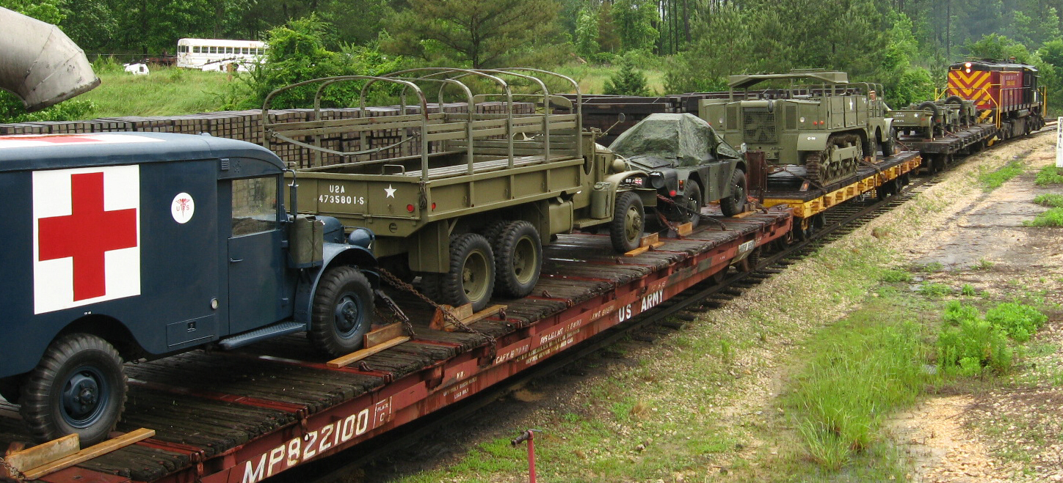

**March 2022**

**Cover Photo; Texas State Railroad military train prepares to depart Rusk yards in the summer of 2008 for Palestine military show and battle. Vehicles (from left to right) 1954 M-43 ambulance, 1945 CCKW, 1956 Ferret Mk.2/3, M5A4 artillery tractor, (barely visible)1943 Dodge WC-51, 1941 Slat Grill Willys and 1942 GPW, both with trailers.**

**Mission Statement: To provide an organization for military vehicle enthusiasts, historians, preservationists, and collectors interested in the acquisition, restoration, preservation, safe operation, public education and display of historic military transport.**

**New Chapter Officers;**

Mike Balfay, President[mikebalfay@gmail.com](mailto:mikebalfay@gmail.com)

Rick Ellison, vice president rick73aggie@dishmail.com

Carolyn Powell, Secretary [carolynsrlp@yahoo.com](mailto:carolynsrlp@yahoo.com)

Larry Powell, Treasurer [carolynsrlp@yahoo.com](mailto:carolynsrlp@yahoo.com)

Tom Townsend, Newsletter Editor [tomtoyland2@gmail.com](mailto:tomtoyland2@gmail.com)

Richard Maddox, web master 87928s4@gmail.com

Next Meeting

March 12; (Saturday) Smoke Monkey restaurant at 19785 Hwy. 155 in Flint Tx. 75762. We will meet at 11 AM.

**Up-coming military vehicle events**

March 12; Chapter meeting at Smoke Monkey Restaurant.

March 26 & 27; Museum of the American G.I., College Station TX. show and swap meet.

April 9; Bullard TX, military swap meet, down town Bullard at railroad tracks. Military vehicles and parts, uniforms, field gear and all militaria , firearms and ammo Okay. Put on by East Texas Piney Woods chapter MVPA. 20’ by 20’ vendor spaces $20.00 contact Mike Balfay @903-521-7971 [mikebalfay@gmail.com](mailto:mikebalfay@gmail.com)

April 21; Medal of Honor Parade, Gainsville.

May 21; car show with military class. Flint Baptist Church, Flint. Contact Larry Powell 903-570-4196 [carolynsrlp@yahoo.com](mailto:carolynsrlp@yahoo.com)

April 23 & 2; Camp Mabry Muster Day, Austin. Military displays and battle.

May 13-14-15; Waco, TX. Tactical event. No other information at this time.

May 30; Veteran’s Cemetery, Hwy 64 West, Tyler. For more information contact Mike Balfay.

October 8; Texas Veterans Military Show, Bullard, TX





the East Texas Piney Woods Motor Pool, fill out the following and mail to the address below.

Name_______________________________

Spouse _____________________________

Address_____________________________

City, State, Zip________________________

Phone (H) ____________________________

Phone (C)____________________________Email_______________________________

Military Vehicle_______________________

Cost to Join: **$20**

Mail To The Treasurer:

**ETPWMP**

**Larry Powell**

**19350 Norfolk Dr.**

**Flint, Tx. 75762**